The Carbon Bathtub – Infographic

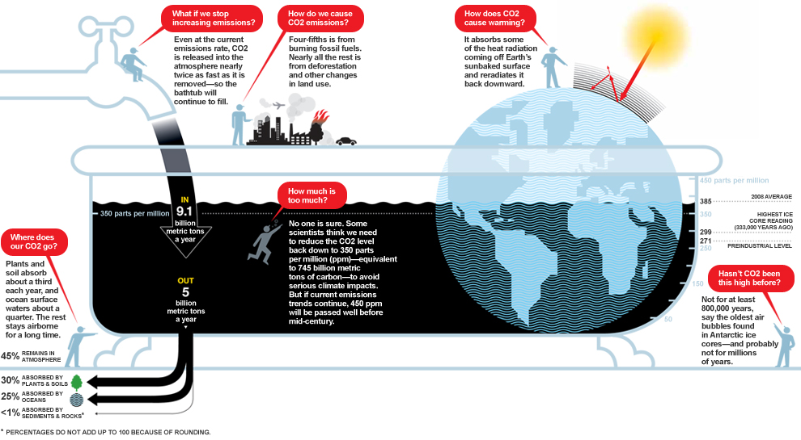

Source: National Geographic (2009): The Big Idea: The Carbon Bathtub. URL [accessed Aug. 7th, 2013]: http://ngm.nationalgeographic.com/big-idea/05/carbon-bath

The Drains of Carbon Bathtub - Infographic 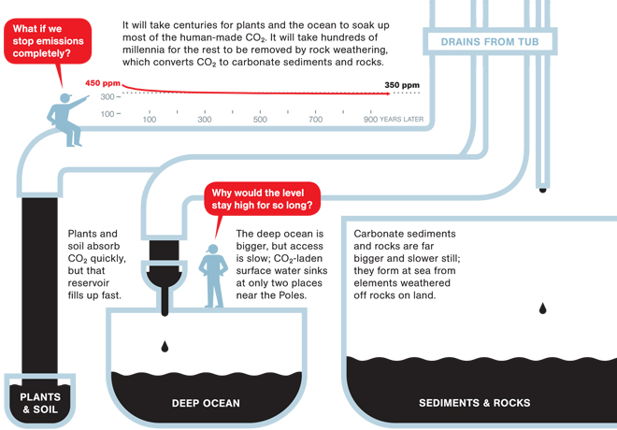

Source: National Geographic (2009): The Big Idea: The Carbon Bathtub. URL [accessed Aug. 7th, 2013]: http://ngm.nationalgeographic.com/big-idea/05/carbon-bath

